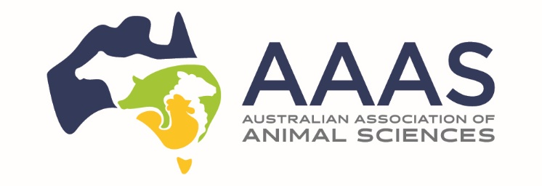 | South Australian  2026 Conference Travel Bursary
Application Form
1. Personal Details
Title: | (i.e. Dr, Mr, Mrs, Ms, Miss) |  | Family name: |  |  |  |  |  |  |  |  |  | Given name(s):
Date of Birth: |  |  |  |  | / |  |  |  | / |  |  |  | Gender |  | Male: |  |  |  | Female:
 |  |  | (Day/Month/Year) |  |  |  |  |  |  |  |  |  |  | Prefer not to disclose: |  |  |  |  | Other:
 |  |  | This travel / conference bursary provides assistance for potential applicants without alternate funding. |  |  |  |  |  |  |  |  |  | (Please tick appropriate box)
Current Mailing Address:
State: |  |  |  |  |  | Postcode: |  |  |  |  |  |  |  |  |  | Country:
Email:
Telephone: |  |  |  |  |  |  |  |  |  |  | Mobile:

2. Benefit Statement
Please outline how the 2026 AAAS Conference Travel Bursary for a South Australian would assist and support your professional development in a field related to Animal Science (≤ 500 words):

3. Budget Estimate Statement
Other Funding and Scholarships
Are you currently in receipt of any Scholarships? |  |  | Yes: |  | No:
(Please tick appropriate box)
If yes, provide details below:
Scholarship(s) held:
With respect to your proposed travel for the AAAS 2026 Conference Travel Bursary, have you applied
for, received or do you expect to receive funding from another source? |  |  | Yes: |  | No:
(Please tick appropriate box)
Please provide a brief budget below of the estimated expenses for your attendance to the 2026 AAAS Conference in Adelaide, South Australia – this bursary provides $500 towards registration, accommodation and travel expenses.
 | Description (e.g. airfares, accommodation, conference registration fees etc.) |  |  |  | Amount (Approx. in AU$)
1 |  |  |  |  | $
2 |  |  |  |  | $
3 |  |  |  |  | $
4 |  |  |  |  | $
5 |  |  |  |  | $
 | Total cost of travel |  |  |  | $
 | Funds from other sources (please specify) |  |  |  | $

4. Declaration
- I certify that I have read and understood the questions on this form and that the answers provided on this form are true and correct.
- I understand that giving false or misleading information is a serious offence under the Criminal Code (Australian Commonwealth).
- I understand that the AAAS may vary or cancel any decision made based on incorrect or incomplete information provided by me.
- I acknowledge that the AAAS may use some information from this application for publicity purposes.
- Within 1 week of the end of the Conference, I will provide a brief, 1-page report that describes the highlights and value of your participation, and a photo, that AAAS and Livestock SA can use to support a media release.

Please sign and date this declaration before emailing.

Your application will not be processed if it has not been signed below.

Signed: |  | Date: |  | / |  | /

5. Submitting the Application Form and Supporting Documentation
Please ensure that you complete all sections of the Application Form and provide a copy of your submitted paper as a single pdf document and a copy of receipt of your Conference Registration.

You must sign the declaration before emailing your completed application to Kylie Falconer, AAAS Executive Officer (eo@aaas.asn.au).

Applications close on Friday 8th May, 2026.

Within 1 week of the end of the Conference, provide a brief, 1-page report that describes the highlights and value of your participation, and a photo, that AAAS and Livestock SA can use to support a media release.

AAAS South Australian Member 2026 AAAS Conference / travel bursary enquiries should be directed to: Bruce Hancock: brucehanock01@bigpond.com or M: 0488 012 829.

